Please make surre your answers are clear….

Question 1: Construct truth table for letter d,f,g ONLY!!!!
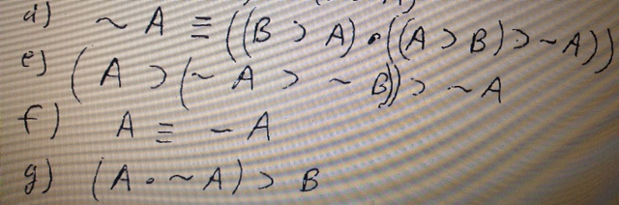
…………………………………………………………………………………………………………………………………
Question 2: run each sentence on the left through all of the sentence forms on the right and note whether it is or is not a substitution instance of that sentence form. For only number 11 and 15 JUST write the right letter ( which is the right answer) next to its number ONLY FOR 11 ANS 15

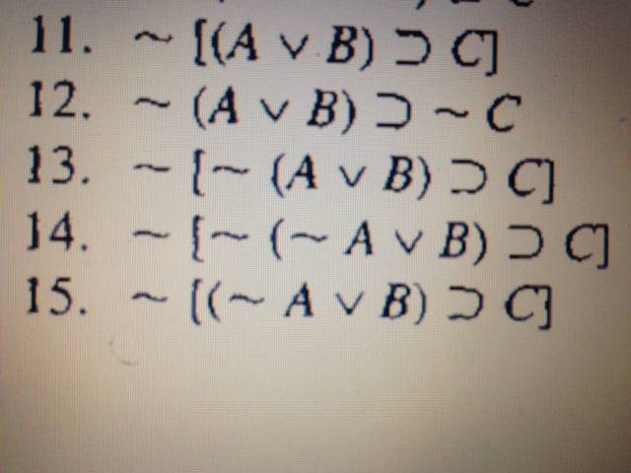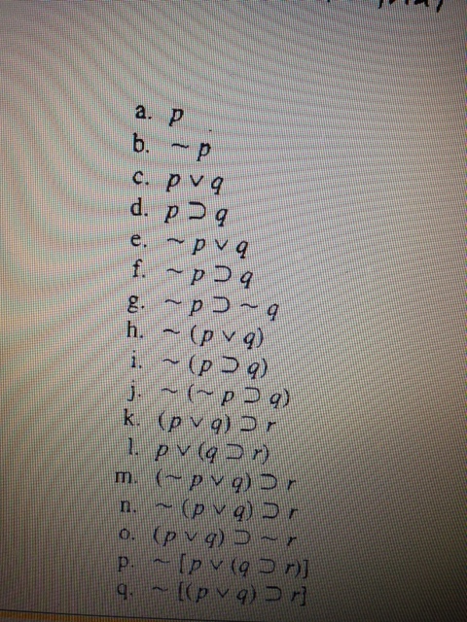
……………………………………………………………………………………………………………………………………………………
Question 3: use MP,MT,DS, And HS to prove that the following arguments are valid. You must include the premises in the proof #1,3,5,9,11
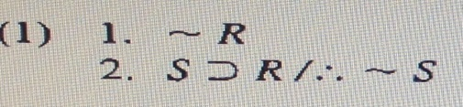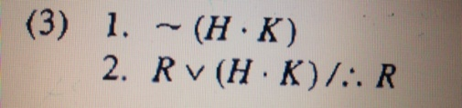
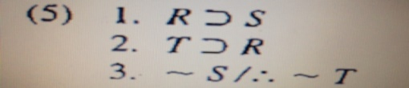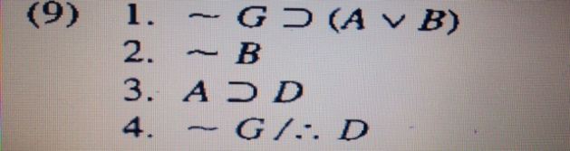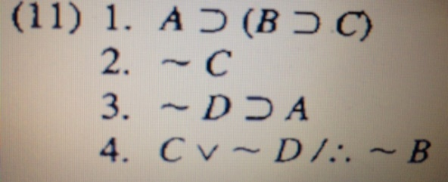
Here is one example and its solution on how I want you to answer the above question
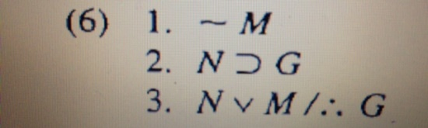 solution> 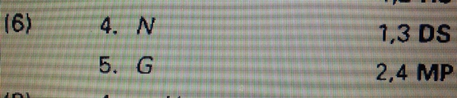
………………………………………………………………………………………………………………………………………………………………
Question 4: use the eight implicational argument forms to prove that the following arguments are valid. Include premises in the proof.
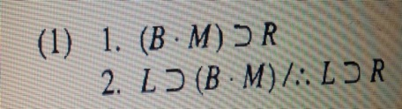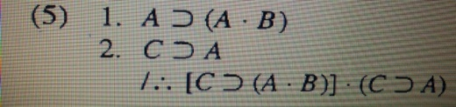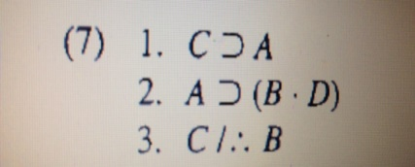
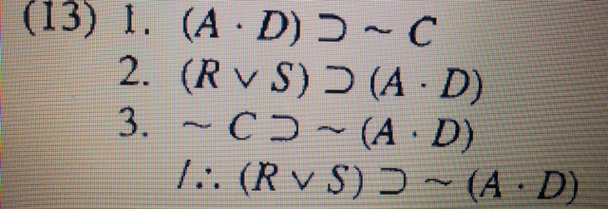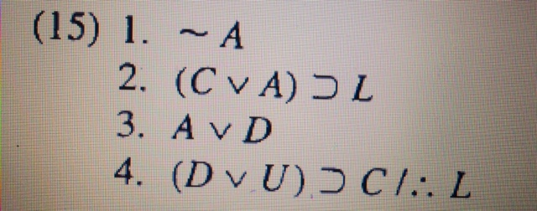
………………………………………………………………………………………………………………..
Question 5: using the eighteen valid arqument forms. Prove that the following arguments are valid. ( these proofs are very basic. None requires more than six additional lines to complete
